Women Healing the Wounds
LOCAL SHELTER
[Phone]
LOCAL SHELTER
[Phone]
LOCAL SHELTER
[Phone]
LOCAL SHELTER
[Phone]
LOCAL SHELTER
[Phone]
LOCAL SHELTER
[Phone]
LOCAL SHELTER
[Phone]
LOCAL SHELTER
[Phone]
LOCAL SHELTER
[Phone]
LOCAL SHELTER
[Phone]
LOCAL SHELTER
[Phone]
LOCAL SHELTER
[Phone]
LOCAL SHELTER
[Phone]
The National Council of Catholic Women
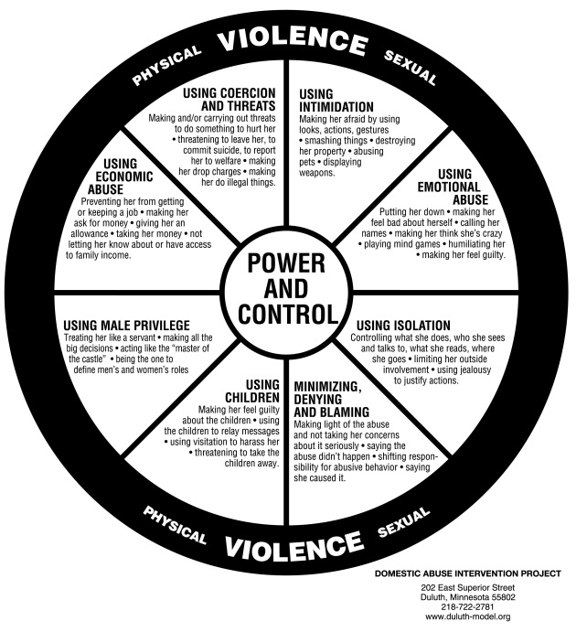
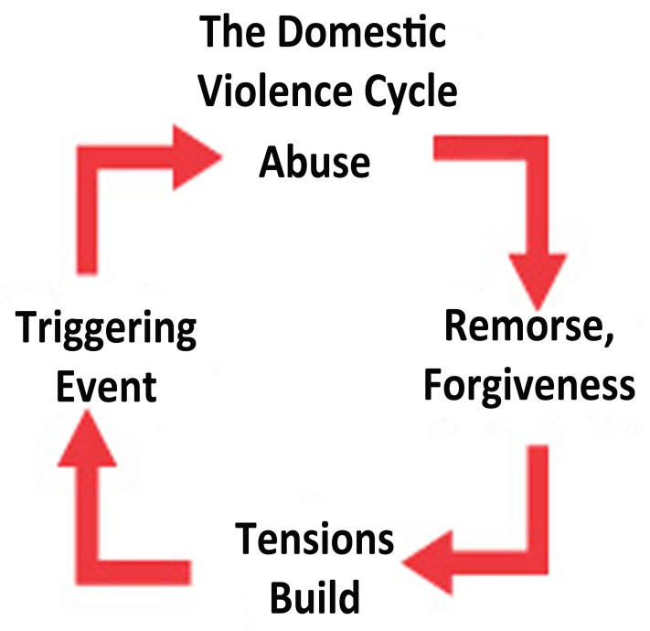
Cares About Your Safety
- Make a safety plan
- Contact a local shelter
- It is not Your Fault

You are not alone, there is help for you
Nearly 75% of men who abuse their partners also abuse their children. Many times they are forced to witness the abuse. Children who grow up in abusive households are 42% more likely to perpetuate the cycle of violence.
1-800-799-SAFE (7233)

